|  |  |
| --- | --- |
|  | **YEAR 12 MATHEMATICS SPECIALIST**  **SEMESTER ONE 2017**  **QUESTIONS OF REVIEW 1: Polynomials & Polars** |

Name: _______________________

Friday 17h February Time: 30 minutes Mark /30

Calculator free.

### [4 marks – 2 each]

Convert:

#### to polars

#### to rectangular co-ordinates

### [4 marks – 1 each]

For , evaluate:

#### 

#### 

#### 

#### , with a real denominator

### [6 marks – 1, 2, 1, 1, 1]

If  and , determine, in *cis* form:

#### 

#### 

#### 

#### 

#### 

### [8 marks – 1, 1, 1, 1, 1, 2, 1]

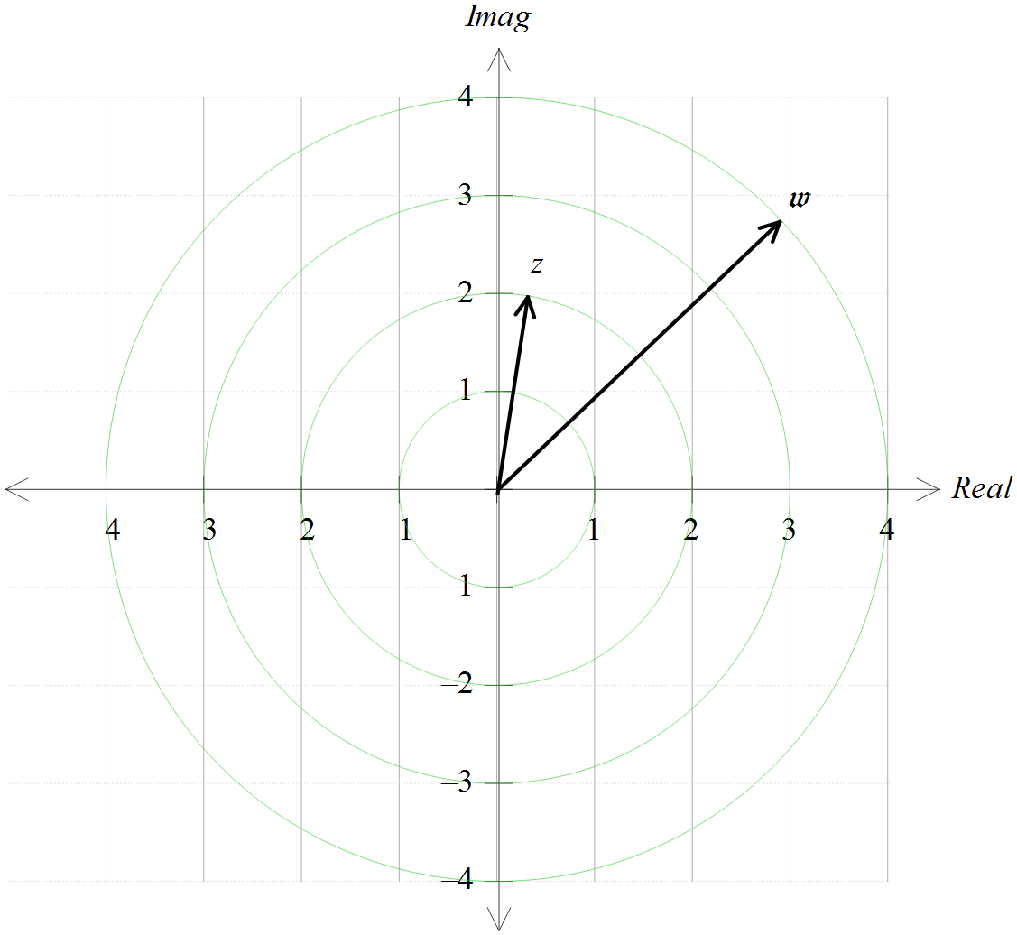Two complex numbers,  and  are shown on the Argand diagram. Add each of these to this diagram:

#### 

#### 

#### 

#### 

#### 

#### 

#### 

### [8 marks – 1, 1, 1, 2, 3]

For 

#### express in terms of *a*

#### determine the remainder, in terms of *a*, when is divided by

#### evaluate *a* if:

#### write a polynomial expression for

#### find all the roots of